**DATABASE MANAGEMENT PROJECT**

**OĞULCAN YUSUF AKÇAY**

Analysis

(2 pts for each website) Examine the websites below and write the data requirements for each website that fit the main scenario above.

1. <https://www.turkishairlines.com>

-every passenger has an unique passenger_ssn, phone no, name, email and date of birth.

-every ticket has a unique id, ticket type, flight id, passenger snn, seat number, ticket price and ticket id.

--every flight has a unique id, a flight number which indicates the flights number, a arrival and departure airport name and arrival time and departure airport code.

-every aircraft has a unique id and capacity number.

-every airport has a unique airport code, airport name, city and country.

-every passenger can have single or multiple tickets, but every ticket must connected to a only single passenger.

-every ticket must have booked to only 1 flight , but every flight can have multiple tickets.

-an aircraft flies from only one flight at a time and a flight only can have 1 aircraft.

-an aircraft can have operate in multiple airports and an airport can have multiple aircrafts too.

-an airport can have many flight but a flight only have 1 departure and arrival airport.

-every passenger can have single or multiple flights and every flight can have multiple flights too.

1. <https://www.tcddtasimacilik.gov.tr/seferler/yuksek-hizli-tren?date=2022-09-18>

-every route has a unique id, a travel time, a arrival and departure station name and train id and departure station code

-every train have a unique id, a train number and capacity.

-every station have a station name, station code which is unique and a city.

-every passenger has name, unique ssn, e mail, phone, date of birth.

-every ticket has a unique id, departure time, train id, ticket price, seat number, passenger ssn and arrival time.

-every route only can have one train and every train only can have one route at a time.

-every train departs and arrivals from only one station at a time but station can have multiple arriving or departing trains.

-every passenger boards many trains and a train can have multiple passengers.

-every passenger can have multiple tickets but a ticket must have only one passenger.

1. <https://www.marti.tech>

-every user will have a unique id, location, phone number, email, name and card balance information.

-every scooter has an unique id, rented information, battery percentage and location info.

-when a scooter rented, there will be a rent end and start time and there must be a charge information so user can pay the charge.

-every user can only use an one scooter at a time and every scooter can only have only one user too.

1. <https://www.obilet.com>

-every passenger have email, a unique ssn, phone number and a gender information.

-every ticket has ticket id, passenger ssn, bus id, seat number, departure location, arrival time, price, arrival location, travel time, departure time.

-every bus have firm name, a unique id, capacity.

-a passenger can have single or multiple tickets but every tickets must have buyed by only one passenger.

-every ticket have to related with one bus but every bus can have multiple tickets that about itself.

1. <https://www.ido.com.tr>

Must have a unique identifier for each passenger (ssn).

Balance is the amount of money associated with each passenger.

Must have a unique identifier for each ferry (ferry_id).

Arrival_time, departure_time, arrival_place, departure_place, and ship_type are required attributes for each ferry.

Must have a unique identifier for each ticket (ticket_id).

Passenger_ssn and ferry_id are foreign keys, linking each ticket to a specific passenger and ferry.

Seat_number, ticket_price, and purchase_time are essential attributes for each ticket.

A passenger can purchase multiple tickets for different ferry trips (One Passenger to Many Tickets).

Each ticket is associated with one specific ferry trip (One Ticket to One Ferry).

Ferries can have multiple associated tickets for different passengers (One Ferry to Many Tickets).

1. <https://www.izban.com.tr/Sayfalar/Anasayfa.aspx>

-every person has ssn which is unique and has balance

-every person can have many card usage but every cars usage must used by single user.

-every card usage has an unique id, arrival and departure station names, person ssn and price.

-every card usages belongs to only one subway but every subway has multiple card usages.

-subway has an unque subway id and route.

1. <https://yolcu360.com>

--every person has balance, email,phone, unique ssn, name and date of birth.

-every rental transaction has car plate, total price, transaction id which is unique, rent end and start time, user ssn.

-every car has unique car plate, model, year, rental price.

-every car can have multiple transactions but every transactions match with only one car.

- every person can rent multiple cars with transactions but every transactions connect with single person.

DESIGN-CONCEPTUAL DESIGN

(3 pts for each EER) Examine the websites below and write the data requirements for each website that fit the main scenario above.

1. <https://www.turkishairlines.com>

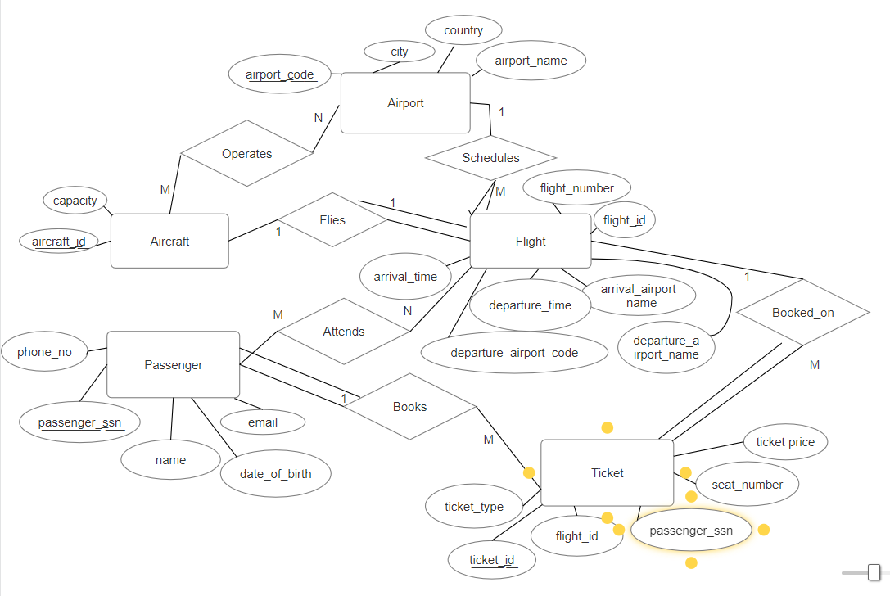

1. <https://www.tcddtasimacilik.gov.tr/seferler/yuksek-hizli-tren?date=2022-09-18>

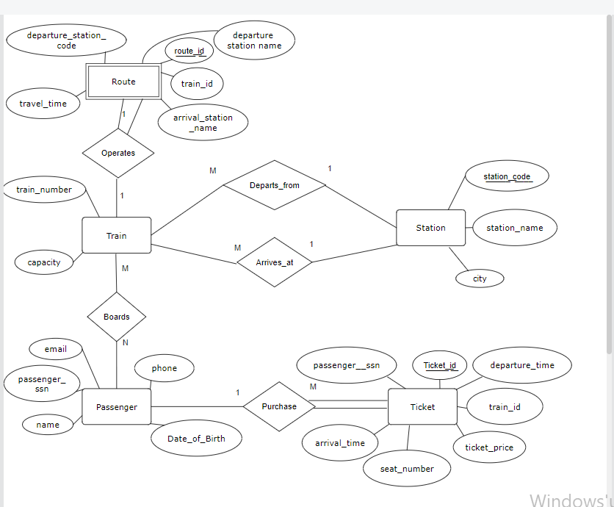

3) <https://www.marti.tech>

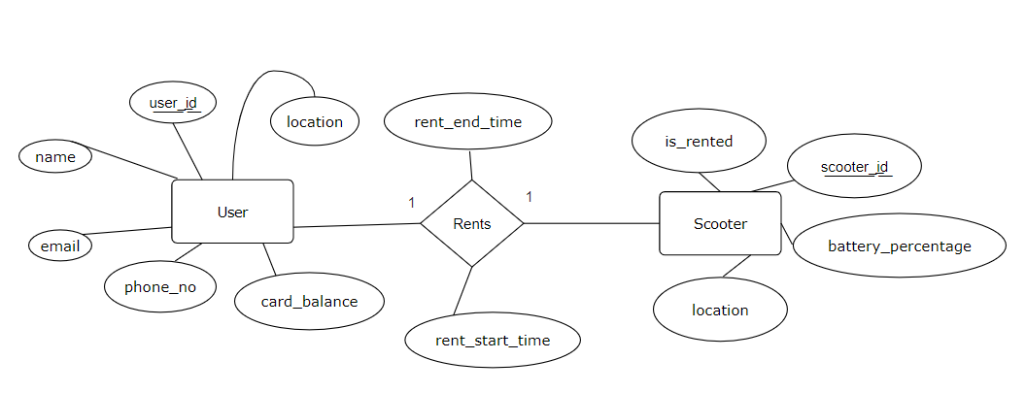

4) <https://www.obilet.com>

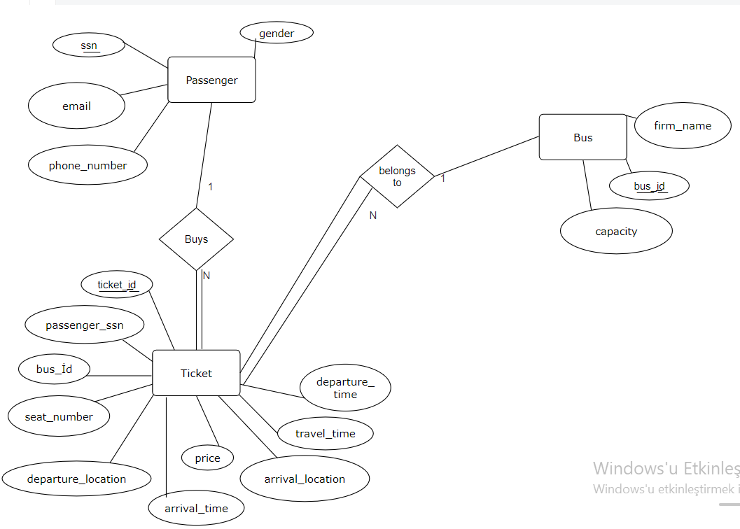

5) <https://www.ido.com.tr>

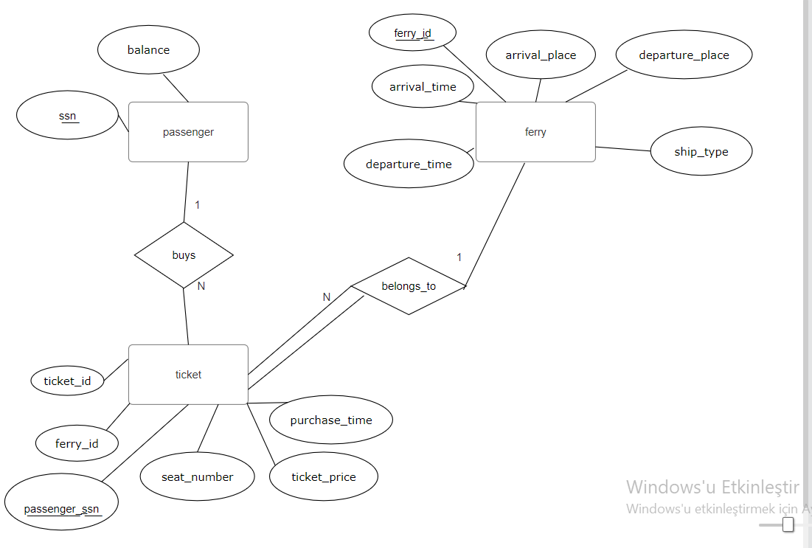

6) <https://www.izban.com.tr/Sayfalar/Anasayfa.aspx>

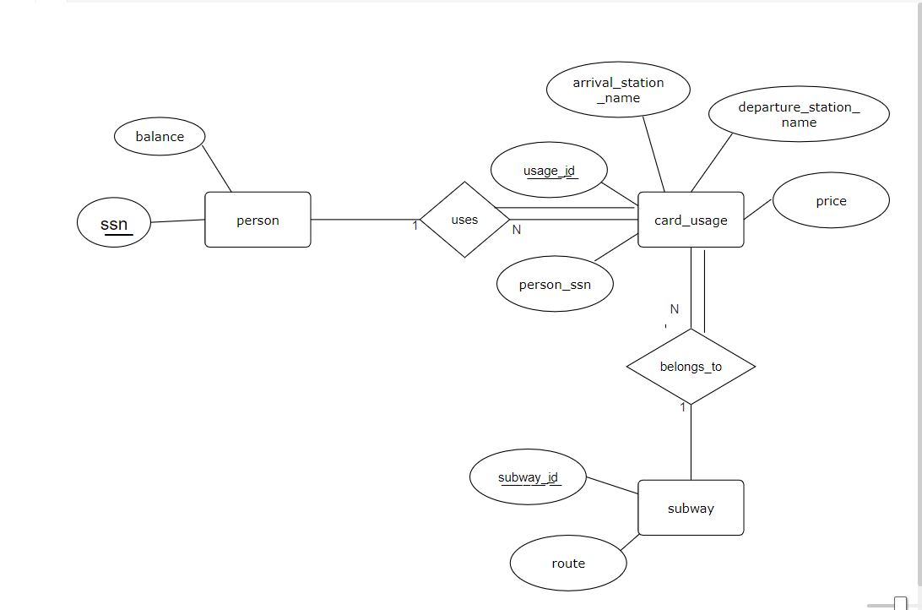

7) <https://yolcu360.com>

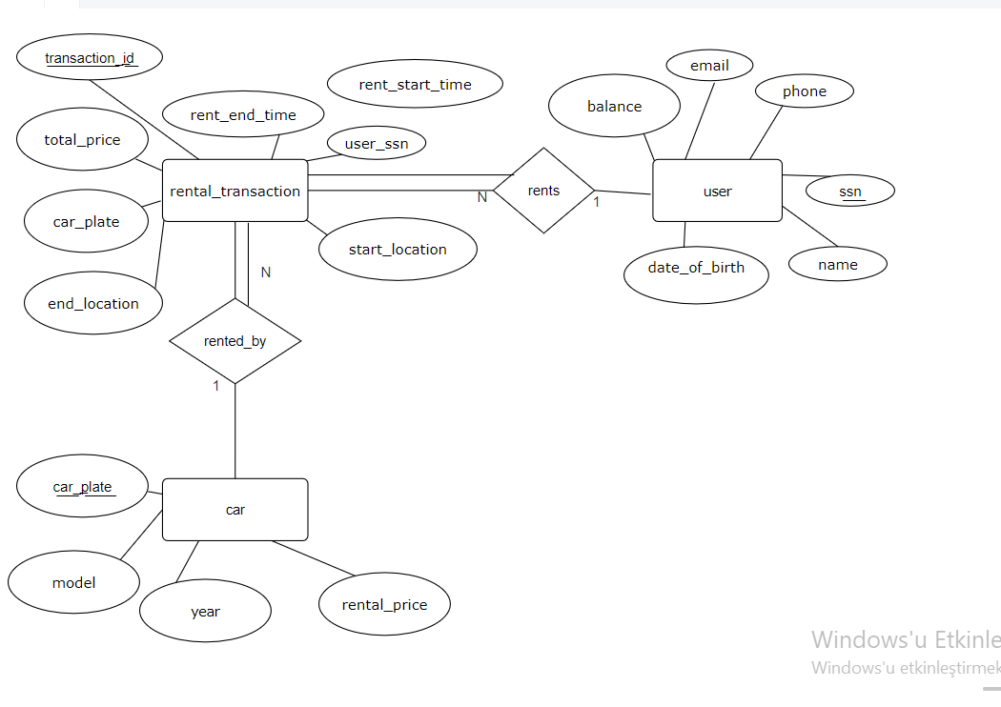

(20) Combine all E2/R diagrams. Explain your method before starting the assembly process.

Steps to Combine EER Diagrams:

1 Identify Common Entities:

Start by identifying common entities among the different systems (e.g., Passenger/User, Vehicle, Card).

2 Define a Common Structure:

Standardize the attributes and relationships for common entities. For example, both the subway and ferry systems have a "Person" or "Passenger" entity.

3 Distinguish System-Specific Entities:

For entities that are specific to each system (e.g., Plane, Subway, Ferry), distinguish them by adding prefixes or tags to their names.

4 Handle Relationships:

Carefully analyze relationships. Ensure that relationships are consistent across systems, and use common terminology.

5 Merge Attributes:

For entities with similar attributes, merge them to create a unified set of attributes.

6 Add System-Specific Details:

Consider adding annotations or notes to specify system-specific details. For example, if a certain attribute is specific to the ferry system, mention that in the diagram.

7 Consolidate Cardinalities:

Ensure that cardinalities (such as 1 to 1, 1 to M, N to M) make sense across the combined system.

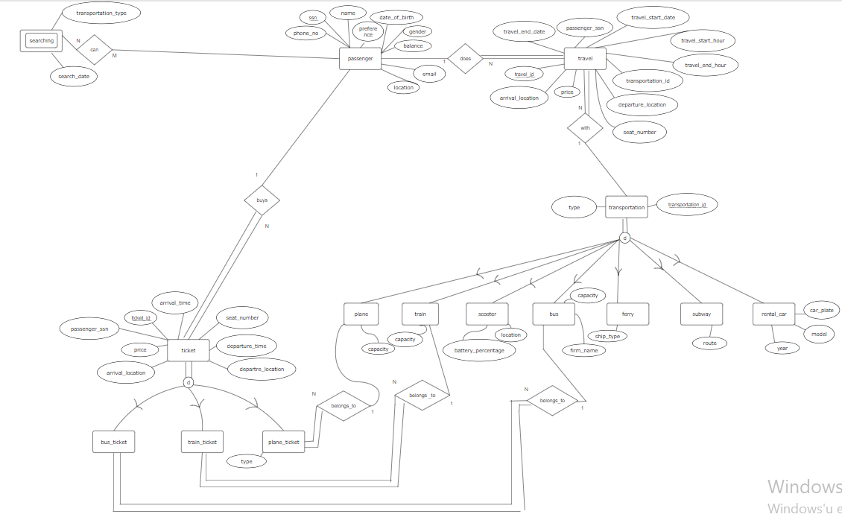

DESIGN-LOGICAL MODEL

(15) Convert EER diagram into a relational model using the methodology that will be introduced in your course.

**Passenger:**

s͟s͟n͟, phone_no, email, location, name, date_of_birth, gender, balance, preference

**Travel:**

t͟r͟a͟v͟e͟l͟_͟i͟d͟, departure_location, arrival_location, price, passenger_ssn(FK from Passenger), travel_start_date, travel_end_date, travel_start_hour, travel_end_hour, transportation_id(FK from Transportation), seat_number

**Transportation**: t͟r͟a͟n͟s͟p͟o͟r͟t͟a͟t͟i͟o͟n͟_͟i͟d͟, type

**Search:** u͟s͟e͟r͟_͟s͟s͟n͟ (FK from Passenger), t͟r͟a͟n͟s͟p͟o͟r͟t͟a͟t͟i͟o͟n͟_͟t͟y͟p͟e͟, s͟e͟a͟r͟c͟h͟_͟d͟a͟t͟e͟

**PLANE:** t͟r͟a͟n͟s͟p͟o͟r͟t͟a͟t͟i͟o͟n͟_͟i͟d͟ (FK from Transportation), capacity

**TRAIN:** t͟r͟a͟n͟s͟p͟o͟r͟t͟a͟t͟i͟o͟n͟_͟i͟d͟ (FK from Transportation), capacity

**SCOOTER:** t͟r͟a͟n͟s͟p͟o͟r͟t͟a͟t͟i͟o͟n͟_͟i͟d͟ (FK from Transportation), battery_percentage, location

**BUS:** t͟r͟a͟n͟s͟p͟o͟r͟t͟a͟t͟i͟o͟n͟_͟i͟d͟ (FK from Transportation), firm_name, capacity

**FERRY:** t͟r͟a͟n͟s͟p͟o͟r͟t͟a͟t͟i͟o͟n͟_͟i͟d͟ (FK from Transportation), ship_type

**SUBWAY:** t͟r͟a͟n͟s͟p͟o͟r͟t͟a͟t͟i͟o͟n͟_͟i͟d͟ (FK from Transportation), route

**CAR:** t͟r͟a͟n͟s͟p͟o͟r͟t͟a͟t͟i͟o͟n͟_͟i͟d͟ (FK from Transportation), year, model, car_plate

**TICKET:** t͟i͟c͟k͟e͟t͟_͟i͟d͟ ,arrival_time, seat_number, departure_time, departure_location, arrival_location, price, user_ssn(FK from Passenger table)

**BUS TICKET:** t͟i͟c͟k͟e͟t͟_͟i͟d͟ (FK from Ticket) transportation_id(FK from Transportation)

**TRAIN_TICKET:** t͟i͟c͟k͟e͟t͟_͟i͟d͟ (FK from Ticket) transportation_id(FK from Transportation)

**PLANE_TICKET** t͟i͟c͟k͟e͟t͟_͟i͟d͟ (FK from Ticket), type, transportation_id(FK from Transportation)

IMPLEMENTATION-PHYSICAL MODEL

(4 pts) Write down the appropriate SQL scripts (DDL statements) for creating the database and its relational model. You can select any of the DBMS you wish.

CREATE TABLE Passenger (

    ssn VARCHAR(15) PRIMARY KEY,

    phone_no VARCHAR(15),

    email VARCHAR(255),

    location VARCHAR(255),

    name VARCHAR(255),

    date_of_birth DATE,

    gender VARCHAR(10),

    balance DECIMAL(10, 2),

    preference VARCHAR(255)

);

CREATE TABLE Transportation (

    transportation_id INT PRIMARY KEY,

    type VARCHAR(255)

);

CREATE TABLE Travel (

    travel_id INT PRIMARY KEY,

    departure_location VARCHAR(255),

    arrival_location VARCHAR(255),

    price DECIMAL(10, 2),

    passenger_ssn VARCHAR(15),

    travel_start_date DATE,

    travel_end_date DATE,

    travel_start_hour TIME,

    travel_end_hour TIME,

    transportation_id INT,

    seat_number INT,

    FOREIGN KEY (passenger_ssn) REFERENCES Passenger(ssn),

    FOREIGN KEY (transportation_id) REFERENCES Transportation(transportation_id)

);

CREATE TABLE Plane (

    transportation_id INT PRIMARY KEY,

    capacity INT,

    FOREIGN KEY (transportation_id) REFERENCES Transportation(transportation_id)

);

CREATE TABLE Train (

    transportation_id INT PRIMARY KEY,

    capacity INT,

    FOREIGN KEY (transportation_id) REFERENCES Transportation(transportation_id)

);

CREATE TABLE Scooter (

    transportation_id INT PRIMARY KEY,

    battery_percentage INT,

    location VARCHAR(255),

    FOREIGN KEY (transportation_id) REFERENCES Transportation(transportation_id)

);

CREATE TABLE Bus (

    transportation_id INT PRIMARY KEY,

    firm_name VARCHAR(255),

    capacity INT,

    FOREIGN KEY (transportation_id) REFERENCES Transportation(transportation_id)

);

CREATE TABLE Ferry (

    transportation_id INT PRIMARY KEY,

    ship_type VARCHAR(255),

    FOREIGN KEY (transportation_id) REFERENCES Transportation(transportation_id)

);

CREATE TABLE Subway (

    transportation_id INT PRIMARY KEY,

    route VARCHAR(255),

    FOREIGN KEY (transportation_id) REFERENCES Transportation(transportation_id)

);

CREATE TABLE Car (

    transportation_id INT PRIMARY KEY,

    year INT,

    model VARCHAR(255),

    car_plate VARCHAR(15),

    FOREIGN KEY (transportation_id) REFERENCES Transportation(transportation_id)

);

CREATE TABLE Search (

    user_ssn VARCHAR(15),

    transportation_type VARCHAR(255),

    search_date DATE,

    FOREIGN KEY (user_ssn) REFERENCES Passenger(ssn),

    PRIMARY KEY (user_ssn, transportation_type, search_date)

);

CREATE TABLE Ticket (

    ticket_id INT PRIMARY KEY,

    arrival_time DATETIME,

    seat_number INT,

    departure_time DATETIME,

    departure_location VARCHAR(255),

    arrival_location VARCHAR(255),

    price DECIMAL(10, 2),

    user_ssn VARCHAR(15),

    FOREIGN KEY (user_ssn) REFERENCES Passenger(ssn)

);

CREATE TABLE Bus_Ticket (

    ticket_id INT PRIMARY KEY,

    transportation_id INT,

    FOREIGN KEY (ticket_id) REFERENCES Ticket(ticket_id),

    FOREIGN KEY (transportation_id) REFERENCES Transportation(transportation_id)

);

CREATE TABLE Train_Ticket (

    ticket_id INT PRIMARY KEY,

    transportation_id INT,

    FOREIGN KEY (ticket_id) REFERENCES Ticket(ticket_id),

    FOREIGN KEY (transportation_id) REFERENCES Transportation(transportation_id)

);

CREATE TABLE Plane_Ticket (

    ticket_id INT PRIMARY KEY,

    type VARCHAR(255),

    transportation_id INT,

    FOREIGN KEY (ticket_id) REFERENCES Ticket(ticket_id),

    FOREIGN KEY (transportation_id) REFERENCES Transportation(transportation_id)

);

(4 pts) Populate the database you just created again using SQL script file loaded with sample tuples. The initial database should have the tuples of our department. (The tables should have enough tuples for the SELECT statements to be run accordingly.)

INSERT INTO Passenger (ssn, phone_no, email, location, name, date_of_birth, gender, balance, preference)

VALUES

('890-12-3416', '555-8901', 'natalie.roberts@example.com', 'San Diego', 'Natalie Roberts', '1986-09-02', 'Female', 120.00, 'Bus'),

('901-23-4557', '555-9012', 'steve.carter@example.com', 'Seattle', 'Steve Carter', '1992-02-15', 'Male', 95.00, 'Ferry'),

('012-34-5698', '555-0123', 'olivia.martinez@example.com', 'Los Angeles', 'Olivia Martinez', '1983-07-22', 'Female', 180.00, 'Car'),

('234-56-7870', '555-2345', 'david.anderson@example.com', 'New York', 'David Anderson', '1990-04-18', 'Male', 150.00, 'Scooter'),

('345-67-8971', '555-3456', 'emily.thompson@example.com', 'San Francisco', 'Emily Thompson', '1995-11-30', 'Female', 130.00, 'Train'),

('456-78-9012', '555-4567', 'alex.wilson@example.com', 'Miami', 'Alex Wilson', '1988-06-12', 'Male', 160.00, 'Plane'),

('567-89-0123', '555-5678', 'sophie.jenkins@example.com', 'Chicago', 'Sophie Jenkins', '1981-03-05', 'Female', 140.00, 'Subway'),

('678-90-1234', '555-6789', 'ryan.morris@example.com', 'Denver', 'Ryan Morris', '1993-09-20', 'Male', 110.00, 'Bus'),

('789-01-2345', '555-7890', 'claire.perez@example.com', 'Philadelphia', 'Claire Perez', '1984-12-15', 'Female', 200.00, 'Ferry'),

('901-23-4567', '555-9012', 'jacob.morgan@example.com', 'Boston', 'Jacob Morgan', '1991-07-08', 'Male', 170.00, 'Car'),

('567-89-0122', '555-5678', 'steven.miller@example.com', 'Seattle', 'Steven Miller', '1987-06-25', 'Male', 95.00, 'Car'),

('668-90-1233', '555-6789', 'jessica.allen@example.com', 'San Francisco', 'Jessica Allen', '1993-10-12', 'Female', 120.00, 'Scooter'),

('789-01-2344', '555-7890', 'ryan.scott@example.com', 'Denver', 'Ryan Scott', '1985-03-28', 'Male', 200.00, 'Train'),

('890-12-3455', '555-8901', 'olivia.baker@example.com', 'Dallas', 'Olivia Baker', '1991-09-15', 'Female', 180.00, 'Ferry'),

('901-23-4566', '555-9012', 'patrick.hill@example.com', 'Boston', 'Patrick Hill', '1988-04-03', 'Male', 150.00, 'Bus'),

('012-34-5677', '555-0123', 'hannah.rogers@example.com', 'Chicago', 'Hannah Rogers', '1996-11-17', 'Female', 130.00, 'Plane'),

('254-56-7898', '555-2345', 'daniel.gomez@example.com', 'Miami', 'Daniel Gomez', '1984-07-20', 'Male', 160.00, 'Subway'),

('345-67-8909', '555-3456', 'laura.collins@example.com', 'Los Angeles', 'Laura Collins', '1990-02-12', 'Female', 140.00, 'Car'),

('456-78-9010', '555-4567', 'jeffrey.hughes@example.com', 'Atlanta', 'Jeffrey Hughes', '1983-08-28', 'Male', 110.00, 'Train'),

('567-89-0121', '555-5678', 'amanda.white@example.com', 'New York', 'Amanda White', '1995-05-10', 'Female', 170.00, 'Scooter'),

('345-67-8901', '555-3456', 'mark.jenkins@example.com', 'Austin', 'Mark Jenkins', '1984-02-14', 'Male', 90.00, 'Scooter'),

('456-78-9012', '555-4567', 'natalie.morris@example.com', 'Phoenix', 'Natalie Morris', '1994-10-08', 'Female', 170.00, 'Subway'),

('567-89-0123', '555-5678', 'kevin.ward@example.com', 'Dallas', 'Kevin Ward', '1986-06-28', 'Male', 110.00, 'Bus'),

('678-90-1234', '555-6789', 'linda.martin@example.com', 'Philadelphia', 'Linda Martin', '1996-12-18', 'Female', 190.00, 'Ferry'),

('789-01-2345', '555-7890', 'michael.rivera@example.com', 'Detroit', 'Michael Rivera', '1983-04-03', 'Male', 120.00, 'Car'),

('890-12-3456', '555-8901', 'amy.collins@example.com', 'Minneapolis', 'Amy Collins', '1990-09-17', 'Female', 150.00, 'Train'),

('901-23-4567', '555-9012', 'chris.jackson@example.com', 'Portland', 'Chris Jackson', '1989-03-12', 'Male', 80.00, 'Scooter'),

('012-34-5678', '555-0123', 'sandra.hernandez@example.com', 'Miami', 'Sandra Hernandez', '1992-07-26', 'Female', 160.00, 'Plane'),

('234-56-7890', '555-2345', 'jason.barnes@example.com', 'San Diego', 'Jason Barnes', '1981-11-20', 'Male', 130.00, 'Subway'),

('345-67-8909', '555-3456', 'amanda.king@example.com', 'New Orleans', 'Amanda King', '1997-05-05', 'Female', 140.00, 'Bus'),

('111-22-3333', '555-1111', 'john.doe@example.com', 'New York', 'John Doe', '1990-01-01', 'Male', 100.00, 'Car'),

('222-33-4444', '555-2222', 'jane.smith@example.com', 'Los Angeles', 'Jane Smith', '1995-05-15', 'Female', 150.00, 'Plane'),

('333-44-5555', '555-3333', 'mike.johnson@example.com', 'Chicago', 'Mike Johnson', '1988-07-20', 'Male', 120.00, 'Train'),

('444-55-6666', '555-4444', 'susan.white@example.com', 'San Francisco', 'Susan White', '1982-09-10', 'Female', 200.00, 'Subway'),

('555-66-7777', '555-5555', 'david.miller@example.com', 'Houston', 'David Miller', '1993-03-25', 'Male', 80.00, 'Bus'),

('666-77-8888', '555-6666', 'lisa.green@example.com', 'Miami', 'Lisa Green', '1985-12-05', 'Female', 180.00, 'Ferry'),

('777-88-9999', '555-7777', 'peter.jones@example.com', 'Seattle', 'Peter Jones', '1998-06-15', 'Male', 110.00, 'Scooter'),

('888-99-0000', '555-8888', 'emily.davis@example.com', 'Boston', 'Emily Davis', '1980-11-30', 'Female', 130.00, 'Car'),

('991-31-4577', '555-9012', 'meine.diamant@example.com', 'Seattle', 'Teresa Palmer', '1992-02-15', 'Female', 95.00, 'Ferry'),

('012-69-5608', '555-0123', 'my.love@example.com', 'Los Angeles', 'Rachel Weisz', '1983-07-22', 'Female', 180.00, 'Car');

INSERT INTO Transportation (transportation_id, type)

VALUES

(1, 'Car'),

(2, 'Plane'),

(3, 'Train'),

(4, 'Scooter'),

(5, 'Bus'),

(6, 'Ferry'),

(7, 'Subway'),

(8, 'Car'),

(9, 'Plane'),

(10, 'Train'),

(11, 'Scooter'),

(12, 'Bus'),

(13, 'Ferry'),

(14, 'Subway'),

(15, 'Car'),

(16, 'Plane'),

(17, 'Train'),

(18, 'Scooter'),

(19, 'Bus'),

(20, 'Ferry'),

(21, 'Subway');

INSERT INTO Train (transportation_id, capacity)

VALUES

(3, 200),

(10, 250),

(17, 180);

INSERT INTO Scooter (transportation_id, battery_percentage, location)

VALUES

(4, 75, 'City1'),

(11, 60, 'City7'),

(18, 80, 'City12');

INSERT INTO Plane (transportation_id, capacity)

VALUES

(2, 150),

(9, 180),

(16, 200);

INSERT INTO Bus (transportation_id, firm_name, capacity)

VALUES

(5, 'ABC Bus Company', 50),

(12, 'XYZ Transportation', 40),

(19, '123 Bus Service', 60);

INSERT INTO Subway (transportation_id, route)

VALUES

(7, 'Blue Line'),

(14, 'Green Line'),

(21, 'Red Line');

INSERT INTO Ferry (transportation_id, ship_type)

VALUES

(6, 'Passenger Ferry'),

(13, 'Cargo Ferry'),

(20, 'Passenger Ferry');

INSERT INTO Car (transportation_id, year, model, car_plate)

VALUES

(1, 2022, 'Toyota Camry', 'ABC123'),

(8, 2020, 'Honda Civic', 'XYZ456'),

(15, 2021, 'Ford Mustang', '123DEF');

INSERT INTO Search (user_ssn, transportation_type, search_date)

VALUES

('012-34-5678', 'Plane', '2023-09-10'),

('234-56-7890', 'Train', '2023-10-05'),

('012-69-5608', 'Subway', '2023-11-15'),

('991-31-4577', 'Bus', '2023-12-20'),

('567-89-0123', 'Ferry', '2024-01-08'),

('678-90-1234', 'Scooter', '2024-02-14'),

('789-01-2345', 'Car', '2024-03-22');

INSERT INTO Ticket (ticket_id, arrival_time, seat_number, departure_time, departure_location, arrival_location, price, user_ssn)

VALUES

(1, '2023-01-15 10:30:00', 1, '2023-01-15 08:00:00', 'New York', 'Los Angeles', 200.00, '010-34-5698'),

(2, '2023-02-20 15:45:00', 2, '2023-02-20 12:30:00', 'Los Angeles', 'Chicago', 150.00, '012-34-5608'),

(3, '2023-03-10 09:15:00', 3, '2023-03-10 07:30:00', 'Chicago', 'Denver', 120.00, '012-34-5678'),

(4, '2023-04-05 18:00:00', 4, '2023-04-05 16:30:00', 'Denver', 'San Francisco', 100.00, '012-69-5608'),

(5, '2023-05-12 12:45:00', 5, '2023-05-12 10:30:00', 'San Francisco', 'Houston', 80.00, '111-22-3333'),

(6, '2023-06-18 21:30:00', 6, '2023-06-18 19:15:00', 'Houston', 'Miami', 250.00, '123-45-6789'),

(7, '2023-07-25 14:20:00', 7, '2023-07-25 12:00:00', 'Miami', 'Seattle', 120.00, '777-88-9999'),

(8, '2023-08-30 17:10:00', 8, '2023-08-30 15:30:00', 'Seattle', 'Boston', 180.00, '222-33-4444'),

(9, '2023-09-10 09:45:00', 9, '2023-09-10 07:30:00', 'Boston', 'Denver', 150.00, '230-56-7870'),

(10, '2023-10-05 13:30:00', 10, '2023-10-05 11:15:00', 'Denver', 'Atlanta', 130.00, '234-56-7800'),

(11, '2023-11-15 19:20:00', 11, '2023-11-15 17:45:00', 'Atlanta', 'New Orleans', 90.00, '234-56-7890'),

(12, '2023-12-20 22:00:00', 12, '2023-12-20 20:30:00', 'New Orleans', 'Dallas', 120.00, '333-44-5555'),

(13, '2024-01-08 11:15:00', 13, '2024-01-08 09:30:00', 'Dallas', 'Los Angeles', 200.00, '340-67-8971'),

(14, '2024-02-14 16:40:00', 14, '2024-02-14 15:00:00', 'Los Angeles', 'San Diego', 150.00, '345-67-8909'),

(15, '2024-03-22 20:30:00', 15, '2024-03-22 18:45:00', 'San Diego', 'San Francisco', 180.00, '345-67-8001'),

(16, '2024-04-10 08:30:00', 16, '2024-04-10 07:00:00', 'San Francisco', 'Seattle', 160.00, '888-99-0000'),

(17, '2024-05-18 14:15:00', 17, '2024-05-18 12:45:00', 'Los Angeles', 'Dallas', 130.00, '888-99-0000'),

(18, '2024-06-22 17:45:00', 18, '2024-06-22 15:30:00', 'Chicago', 'Houston', 110.00, '888-99-0000'),

(19, '2024-07-05 22:00:00', 19, '2024-07-05 20:30:00', 'Denver', 'New York', 190.00, '888-99-0000'),

(20, '2024-08-12 10:45:00', 20, '2024-08-12 09:15:00', 'Houston', 'San Francisco', 140.00, '888-99-0000'),

(21, '2024-09-20 18:30:00', 21, '2024-09-20 16:45:00', 'Miami', 'Boston', 170.00, '888-99-0000'),

(22, '2024-10-28 12:20:00', 22, '2024-10-28 10:30:00', 'Seattle', 'Los Angeles', 210.00, '999-00-1111'),

(23, '2024-11-15 16:10:00', 23, '2024-11-15 14:30:00', 'Boston', 'Chicago', 120.00, '999-00-1111'),

(24, '2024-12-02 11:30:00', 24, '2024-12-02 09:45:00', 'Denver', 'San Diego', 180.00, '999-00-1111'),

(25, '2025-01-20 09:15:00', 25, '2025-01-20 07:30:00', 'San Francisco', 'Los Angeles', 160.00, '999-00-1111'),

(26, '2025-02-14 14:45:00', 26, '2025-02-14 13:00:00', 'Chicago', 'Miami', 130.00, '999-00-1111'),

(27, '2025-03-22 20:00:00', 27, '2025-03-22 18:15:00', 'Atlanta', 'Houston', 110.00, '560-89-0123'),

(28, '2025-04-08 11:45:00', 28, '2025-04-08 10:00:00', 'Dallas', 'San Diego', 190.00, '560-89-0123'),

(29, '2025-05-15 16:30:00', 29, '2025-05-15 14:45:00', 'New York', 'Chicago', 140.00, '560-89-0123'),

(30, '2025-06-20 22:00:00', 30, '2025-06-20 20:15:00', 'Los Angeles', 'Seattle', 170.00, '560-89-0123'),

(31, '2025-07-10 08:30:00', 31, '2025-07-10 07:00:00', 'San Francisco', 'Seattle', 170.00, '234-56-7890'),

(32, '2025-08-18 14:15:00', 32, '2025-08-18 12:45:00', 'Los Angeles', 'Dallas', 140.00, '234-56-7890'),

(33, '2025-09-22 17:45:00', 33, '2025-09-22 15:30:00', 'Chicago', 'Houston', 120.00, '234-56-7890'),

(34, '2025-10-05 22:00:00', 34, '2025-10-05 20:30:00', 'Denver', 'New York', 200.00, '234-56-7890'),

(35, '2025-11-12 10:45:00', 35, '2025-11-12 09:15:00', 'Houston', 'San Francisco', 150.00, '234-56-7890'),

(36, '2025-12-20 18:30:00', 36, '2025-12-20 16:45:00', 'Miami', 'Boston', 180.00, '234-56-7890'),

(37, '2026-01-28 12:20:00', 37, '2026-01-28 10:30:00', 'Seattle', 'Los Angeles', 220.00, '234-56-7890'),

(38, '2026-02-15 16:10:00', 38, '2026-02-15 14:30:00', 'Boston', 'Chicago', 130.00, '234-56-7890'),

(39, '2026-03-02 11:30:00', 39, '2026-03-02 09:45:00', 'Denver', 'San Diego', 190.00, '234-56-7800'),

(40, '2026-04-20 09:15:00', 40, '2026-04-20 07:30:00', 'San Francisco', 'Los Angeles', 170.00, '234-56-7800'),

(41, '2026-05-14 14:45:00', 41, '2026-05-14 13:00:00', 'Chicago', 'Miami', 140.00, '234-56-7800'),

(42, '2026-06-22 20:00:00', 42, '2026-06-22 18:15:00', 'Atlanta', 'Houston', 120.00, '234-56-7800'),

(43, '2026-07-08 11:45:00', 43, '2026-07-08 10:00:00', 'Dallas', 'San Diego', 200.00, '234-56-7800'),

(44, '2026-08-15 16:30:00', 44, '2026-08-15 14:45:00', 'New York', 'Chicago', 150.00, '234-56-7800'),

(45, '2026-09-20 22:00:00', 45, '2026-09-20 20:15:00', 'Los Angeles', 'Seattle', 180.00, '234-56-7800'),

(46, '2026-10-10 08:30:00', 46, '2026-10-10 07:00:00', 'San Francisco', 'Seattle', 190.00, '012-69-5608'),

(47, '2026-11-18 14:15:00', 47, '2026-11-18 12:45:00', 'Los Angeles', 'Dallas', 160.00, '012-69-5608'),

(48, '2026-12-22 17:45:00', 48, '2026-12-22 15:30:00', 'Chicago', 'Houston', 140.00, '012-69-5608'),

(49, '2027-01-05 22:00:00', 49, '2027-01-05 20:30:00', 'Denver', 'New York', 210.00, '012-69-5608'),

(50, '2027-02-12 10:45:00', 50, '2027-02-12 09:15:00', 'Houston', 'San Francisco', 170.00, '012-69-5608'),

(51, '2027-03-20 18:30:00', 51, '2027-03-20 16:45:00', 'Miami', 'Boston', 200.00, '012-69-5608'),

(52, '2027-04-28 12:20:00', 52, '2027-04-28 10:30:00', 'Seattle', 'Los Angeles', 230.00, '230-56-7870'),

(53, '2027-05-15 16:10:00', 53, '2027-05-15 14:30:00', 'Boston', 'Chicago', 150.00, '230-56-7870'),

(54, '2027-06-02 11:30:00', 54, '2027-06-02 09:45:00', 'Denver', 'San Diego', 220.00, '230-56-7870'),

(55, '2027-07-20 09:15:00', 55, '2027-07-20 07:30:00', 'San Francisco', 'Los Angeles', 190.00, '230-56-7870'),

(56, '2027-08-14 14:45:00', 56, '2027-08-14 13:00:00', 'Chicago', 'Miami', 160.00, '230-56-7870'),

(57, '2027-09-22 20:00:00', 57, '2027-09-22 18:15:00', 'Atlanta', 'Houston', 140.00, '230-56-7870'),

(58, '2027-10-08 11:45:00', 58, '2027-10-08 10:00:00', 'Dallas', 'San Diego', 210.00, '230-56-7870'),

(59, '2027-11-15 16:30:00', 59, '2027-11-15 14:45:00', 'New York', 'Chicago', 170.00, '230-56-7870'),

(60, '2027-12-20 22:00:00', 60, '2027-12-20 20:15:00', 'Los Angeles', 'Seattle', 200.00, '230-56-7870'),

(61, '2028-01-10 08:30:00', 61, '2028-01-10 07:00:00', 'San Francisco', 'Seattle', 200.00, '345-67-8909'),

(62, '2028-02-18 14:15:00', 62, '2028-02-18 12:45:00', 'Los Angeles', 'Dallas', 170.00, '345-67-8909'),

(63, '2028-03-22 17:45:00', 63, '2028-03-22 15:30:00', 'Chicago', 'Houston', 150.00, '345-67-8909'),

(64, '2028-04-05 22:00:00', 64, '2028-04-05 20:30:00', 'Denver', 'New York', 220.00, '345-67-8909'),

(65, '2028-05-12 10:45:00', 65, '2028-05-12 09:15:00', 'Houston', 'San Francisco', 180.00, '345-67-8909'),

(66, '2028-06-20 18:30:00', 66, '2028-06-20 16:45:00', 'Miami', 'Boston', 210.00, '444-55-6666'),

(67, '2028-07-28 12:20:00', 67, '2028-07-28 10:30:00', 'Seattle', 'Los Angeles', 240.00, '444-55-6666'),

(68, '2028-08-15 16:10:00', 68, '2028-08-15 14:30:00', 'Boston', 'Chicago', 160.00, '444-55-6666'),

(69, '2028-09-02 11:30:00', 69, '2028-09-02 09:45:00', 'Denver', 'San Diego', 230.00, '444-55-6666'),

(70, '2028-10-20 09:15:00', 70, '2028-10-20 07:30:00', 'San Francisco', 'Los Angeles', 200.00, '444-55-6666'),

(71, '2028-11-14 14:45:00', 71, '2028-11-14 13:00:00', 'Chicago', 'Miami', 170.00, '444-55-6666'),

(72, '2028-12-22 20:00:00', 72, '2028-12-22 18:15:00', 'Atlanta', 'Houston', 150.00, '444-55-6666'),

(73, '2029-01-08 11:45:00', 73, '2029-01-08 10:00:00', 'Dallas', 'San Diego', 220.00, '444-55-6666'),

(74, '2029-02-15 16:30:00', 74, '2029-02-15 14:45:00', 'New York', 'Chicago', 180.00, '444-55-6666'),

(75, '2029-03-20 22:00:00', 75, '2029-03-20 20:15:00', 'Los Angeles', 'Seattle', 210.00, '444-55-6666'),

(76, '2029-04-10 08:30:00', 76, '2029-04-10 07:00:00', 'San Francisco', 'Seattle', 210.00, '340-67-8971'),

(77, '2029-05-18 14:15:00', 77, '2029-05-18 12:45:00', 'Los Angeles', 'Dallas', 180.00, '340-67-8971'),

(78, '2029-06-22 17:45:00', 78, '2029-06-22 15:30:00', 'Chicago', 'Houston', 160.00, '340-67-8971'),

(79, '2029-07-05 22:00:00', 79, '2029-07-05 20:30:00', 'Denver', 'New York', 230.00, '340-67-8971'),

(80, '2029-08-12 10:45:00', 80, '2029-08-12 09:15:00', 'Houston', 'San Francisco', 190.00, '340-67-8971'),

(81, '2029-09-20 18:30:00', 81, '2029-09-20 16:45:00', 'Miami', 'Boston', 220.00, '340-67-8971'),

(82, '2029-10-28 12:20:00', 82, '2029-10-28 10:30:00', 'Seattle', 'Los Angeles', 250.00, '340-67-8971'),

(83, '2029-11-15 16:10:00', 83, '2029-11-15 14:30:00', 'Boston', 'Chicago', 170.00, '340-67-8971'),

(84, '2029-12-02 11:30:00', 84, '2029-12-02 09:45:00', 'Denver', 'San Diego', 240.00, '340-67-8971'),

(85, '2030-01-20 09:15:00', 85, '2030-01-20 07:30:00', 'San Francisco', 'Los Angeles', 210.00, '340-67-8971'),

(86, '2030-02-14 14:45:00', 86, '2030-02-14 13:00:00', 'Chicago', 'Miami', 180.00, '340-67-8971'),

(87, '2030-03-22 20:00:00', 87, '2030-03-22 18:15:00', 'Atlanta', 'Houston', 160.00, '340-67-8971'),

(88, '2030-04-08 11:45:00', 88, '2030-04-08 10:00:00', 'Dallas', 'San Diego', 230.00, '340-67-8971'),

(89, '2030-05-15 16:30:00', 89, '2030-05-15 14:45:00', 'New York', 'Chicago', 190.00, '340-67-8971'),

(90, '2030-06-20 22:00:00', 90, '2030-06-20 20:15:00', 'Los Angeles', 'Seattle', 220.00, '340-67-8971');

INSERT INTO Plane_Ticket (ticket_id, transportation_id)

VALUES

(1, 2),

(2, 2),

(3, 2),

(4, 2),

(5, 2),

(6, 2),

(7, 2),

(8, 2),

(9, 2),

(10, 2),

(11, 9),

(12, 9),

(13, 9),

(14, 9),

(15, 9),

(16, 9),

(17, 9),

(18, 9),

(19, 9),

(20, 9),

(21, 16),

(22, 16),

(23, 16),

(24, 16),

(25, 16),

(26, 16),

(27, 16),

(28, 16),

(29, 16),

(30, 16);

UPDATE plane_ticket

SET type = 'economic'

WHERE ticket_id = 1;

UPDATE plane_ticket

SET type = 'economic'

WHERE ticket_id = 2;

UPDATE plane_ticket

SET type = 'business'

WHERE ticket_id = 3;

UPDATE plane_ticket

SET type = 'economic'

WHERE ticket_id = 4;

UPDATE plane_ticket

SET type = 'economic'

WHERE ticket_id = 5;

UPDATE plane_ticket

SET type = 'business'

WHERE ticket_id = 6;

UPDATE plane_ticket

SET type = 'economic'

WHERE ticket_id = 7;

UPDATE plane_ticket

SET type = 'economic'

WHERE ticket_id = 8;

UPDATE plane_ticket

SET type = 'business'

WHERE ticket_id = 9;

UPDATE plane_ticket

SET type = 'economic'

WHERE ticket_id = 10;

UPDATE plane_ticket

SET type = 'business'

WHERE ticket_id = 11;

UPDATE plane_ticket

SET type = 'economic'

WHERE ticket_id = 12;

UPDATE plane_ticket

SET type = 'economic'

WHERE ticket_id = 13;

UPDATE plane_ticket

SET type = 'economic'

WHERE ticket_id = 14;

UPDATE plane_ticket

SET type = 'economic'

WHERE ticket_id = 15;

UPDATE plane_ticket

SET type = 'economic'

WHERE ticket_id = 16;

UPDATE plane_ticket

SET type = 'business'

WHERE ticket_id = 17;

UPDATE plane_ticket

SET type = 'economic'

WHERE ticket_id = 18;

UPDATE plane_ticket

SET type = 'economic'

WHERE ticket_id = 19;

UPDATE plane_ticket

SET type = 'economic'

WHERE ticket_id = 20;

UPDATE plane_ticket

SET type = 'economic'

WHERE ticket_id = 21;

UPDATE plane_ticket

SET type = 'business'

WHERE ticket_id = 22;

UPDATE plane_ticket

SET type = 'economic'

WHERE ticket_id = 23;

UPDATE plane_ticket

SET type = 'business'

WHERE ticket_id = 24;

UPDATE plane_ticket

SET type = 'economic'

WHERE ticket_id = 25;

UPDATE plane_ticket

SET type = 'economic'

WHERE ticket_id = 26;

UPDATE plane_ticket

SET type = 'economic'

WHERE ticket_id = 27;

UPDATE plane_ticket

SET type = 'economic'

WHERE ticket_id = 28;

UPDATE plane_ticket

SET type = 'business'

WHERE ticket_id = 29;

UPDATE plane_ticket

SET type = 'business'

WHERE ticket_id = 30;

INSERT INTO Bus_Ticket (ticket_id, transportation_id)

VALUES

(31, 5),

(32, 5),

(33, 5),

(34, 5),

(35, 5),

(36, 5),

(37, 5),

(38, 5),

(39, 5),

(40, 5),

(41, 12),

(42, 12),

(43, 12),

(44, 12),

(45, 12),

(46, 12),

(47, 12),

(48, 12),

(49, 12),

(50, 12),

(51, 19),

(52, 19),

(53, 19),

(54, 19),

(55, 19),

(56, 19),

(57, 19),

(58, 19),

(59, 19),

(60, 19);

INSERT INTO Train_Ticket (ticket_id, transportation_id)

VALUES

(61, 3),

(62, 3),

(63, 3),

(64, 3),

(65, 3),

(66, 3),

(67, 3),

(68, 3),

(69, 3),

(70, 3),

(71, 10),

(72, 10),

(73, 10),

(74, 10),

(75, 10),

(76, 10),

(77, 10),

(78, 10),

(79, 10),

(80, 10),

(81, 17),

(82, 17),

(83, 17),

(84, 17),

(85, 17),

(86, 17),

(87, 17),

(88, 17),

(89, 17),

(90, 17);

-- Inserting sample data into the Travel table

INSERT INTO Travel (travel_id, departure_location, arrival_location, price, passenger_ssn, travel_start_date, travel_end_date, travel_start_hour, travel_end_hour, transportation_id, seat_number)

VALUES

(1, 'New York', 'Los Angeles', 250.00, '010-34-5698', '2023-12-01', '2023-12-05', '08:00:00', '14:00:00', 2, '101'),

(2, 'Chicago', 'Miami', 180.00, '012-34-5608', '2023-12-10', '2023-12-15', '10:30:00', '16:30:00', 2, '202'),

(3, 'San Francisco', 'Houston', 200.00, '012-34-5678', '2023-12-20', '2023-12-25', '12:45:00', '18:45:00', 2, '303'),

(4, 'Los Angeles', 'Chicago', 220.00, '012-69-5608', '2024-01-05', '2024-01-10', '14:00:00', '20:00:00', 2, '404'),

(5, 'Miami', 'New York', 190.00, '111-22-3333', '2024-01-15', '2024-01-20', '16:30:00', '22:30:00', 2, '505'),

(6, 'Houston', 'San Francisco', 210.00, '123-45-6789', '2024-02-01', '2024-02-05', '18:45:00', '00:45:00', 2, '606'),

(7, 'Boston', 'Atlanta', 160.00, '777-88-9999', '2024-02-10', '2024-02-15', '08:30:00', '14:30:00', 2, '707'),

(8, 'Seattle', 'Denver', 180.00, '222-33-4444', '2024-02-20', '2024-02-25', '10:00:00', '16:00:00', 2, '808'),

(9, 'Atlanta', 'San Diego', 230.00, '230-56-7870', '2024-03-05', '2024-03-10', '12:15:00', '18:15:00', 2, '9'),

(10, 'San Diego', 'Seattle', 190.00, '234-56-7800', '2024-03-15', '2024-03-20', '14:45:00', '20:45:00', 2, '10'),

(11, 'Dallas', 'Houston', 150.00, '234-56-7890', '2024-03-25', '2024-03-30', '16:30:00', '22:30:00', 2, '11'),

(12, 'Denver', 'Boston', 200.00, '333-44-5555', '2024-04-01', '2024-04-05', '18:00:00', '00:00:00', 2, '12'),

(13, 'Miami', 'Dallas', 170.00, '340-67-8971', '2024-04-10', '2024-04-15', '08:45:00', '14:45:00', 2, '13'),

(14, 'Los Angeles', 'Seattle', 190.00, '345-67-8909', '2024-04-20', '2024-04-25', '10:15:00', '16:15:00', 2, '14'),

(15, 'Chicago', 'New York', 220.00, '345-67-8001', '2024-05-01', '2024-05-05', '12:30:00', '18:30:00', 2, '15'),

(16, 'Houston', 'Denver', 210.00, '888-99-0000', '2024-05-10', '2024-05-15', '14:30:00', '20:30:00', 9, '16'),

(17, 'Boston', 'Miami', 180.00, '888-99-0000', '2024-05-20', '2024-05-25', '16:45:00', '22:45:00', 9, '7'),

(18, 'Seattle', 'Chicago', 200.00, '888-99-0000', '2024-06-01', '2024-06-05', '18:00:00', '00:00:00', 9, '8'),

(19, 'Atlanta', 'New York', 220.00, '888-99-0000', '2024-06-10', '2024-06-15', '08:15:00', '14:15:00', 9, '9'),

(20, 'Denver', 'Los Angeles', 190.00, '888-99-0000', '2024-06-20', '2024-06-25', '10:30:00', '16:30:00', 9, '20'),

(21, 'San Francisco', 'Seattle', 210.00, '888-99-0000', '2024-07-01', '2024-07-05', '12:45:00', '18:45:00', 9, '1'),

(22, 'Chicago', 'Houston', 160.00, '999-00-1111', '2024-07-10', '2024-07-15', '14:00:00', '20:00:00', 9, '22'),

(23, 'New York', 'Denver', 180.00, '999-00-1111', '2024-07-20', '2024-07-25', '16:15:00', '22:15:00', 9, '3'),

(24, 'Miami', 'San Diego', 230.00, '999-00-1111', '2024-08-01', '2024-08-05', '18:30:00', '00:30:00', 9, '4'),

(25, 'Dallas', 'San Francisco', 190.00, '999-00-1111', '2024-08-10', '2024-08-15', '08:45:00', '14:45:00', 9, '5'),

(26, 'Houston', 'Chicago', 150.00, '999-00-1111', '2024-08-20', '2024-08-25', '10:00:00', '16:00:00', 16, '26'),

(27, 'Atlanta', 'New York', 200.00, '560-89-0123', '2024-09-01', '2024-09-05', '12:15:00', '18:15:00', 16, '27'),

(28, 'Los Angeles', 'Seattle', 170.00, '560-89-0123', '2024-09-10', '2024-09-15', '14:45:00', '20:45:00', 16, '28'),

(29, 'Denver', 'Boston', 190.00, '560-89-0123', '2024-09-20', '2024-09-25', '16:00:00', '22:00:00', 16, '29'),

(30, 'Miami', 'Dallas', 220.00, '560-89-0123', '2024-10-01', '2024-10-05', '18:15:00', '00:15:00', 16, '30'),

(31, 'San Francisco', 'New York', 240.00, '234-56-7890', '2024-10-10', '2024-10-15', '08:30:00', '14:30:00', 5, '31'),

(32, 'Los Angeles', 'Denver', 200.00, '234-56-7890', '2024-10-20', '2024-10-25', '10:45:00', '16:45:00', 5, '32'),

(33, 'Miami', 'Houston', 220.00, '234-56-7890', '2024-11-01', '2024-11-05', '12:00:00', '18:00:00', 5, '3'),

(34, 'Chicago', 'Dallas', 180.00, '234-56-7890', '2024-11-10', '2024-11-15', '14:15:00', '20:15:00', 5, '4'),

(35, 'New York', 'Los Angeles', 200.00, '234-56-7890', '2024-11-20', '2024-11-25', '16:30:00', '22:30:00', 5, '35'),

(36, 'San Diego', 'Seattle', 190.00, '234-56-7890', '2024-12-01', '2024-12-05', '18:45:00', '00:45:00', 5, '36'),

(37, 'Houston', 'Chicago', 170.00, '234-56-7890', '2024-12-10', '2024-12-15', '08:15:00', '14:15:00', 5, '37'),

(38, 'Dallas', 'New York', 230.00, '234-56-7890', '2024-12-20', '2024-12-25', '10:30:00', '16:30:00', 5, '38'),

(39, 'Boston', 'Atlanta', 190.00, '234-56-7800', '2025-01-05', '2025-01-10', '12:45:00', '18:45:00', 5, '39'),

(40, 'Seattle', 'Denver', 210.00, '234-56-7800', '2025-01-15', '2025-01-20', '14:00:00', '20:00:00', 5, '40'),

(41, 'Chicago', 'Houston', 160.00, '234-56-7800', '2025-01-25', '2025-01-30', '16:30:00', '22:30:00', 12, '141'),

(42, 'Denver', 'Boston', 180.00, '234-56-7800', '2025-02-01', '2025-02-05', '18:45:00', '00:45:00', 12, '242'),

(43, 'Miami', 'Dallas', 220.00, '234-56-7800', '2025-02-10', '2025-02-15', '08:30:00', '14:30:00', 12, '43'),

(44, 'Los Angeles', 'Seattle', 190.00, '234-56-7800', '2025-02-20', '2025-02-25', '10:00:00', '16:00:00', 12, '44'),

(45, 'Chicago', 'New York', 210.00, '234-56-7800', '2025-03-01', '2025-03-05', '12:15:00', '18:15:00', 12, '5'),

(46, 'San Francisco', 'Houston', 200.00, '012-69-5608', '2025-03-10', '2025-03-15', '14:30:00', '20:30:00', 12, '6'),

(47, 'Miami', 'New York', 180.00, '012-69-5608', '2025-03-20', '2025-03-25', '16:45:00', '22:45:00', 12, '47'),

(48, 'Seattle', 'Chicago', 210.00, '012-69-5608', '2025-04-01', '2025-04-05', '18:00:00', '00:00:00', 12, '8'),

(49, 'Atlanta', 'San Diego', 220.00, '012-69-5608', '2025-04-10', '2025-04-15', '08:15:00', '14:15:00', 12, '9'),

(50, 'Denver', 'Los Angeles', 190.00, '012-69-5608', '2025-04-20', '2025-04-25', '10:30:00', '16:30:00', 12, '0'),

(51, 'San Francisco', 'Seattle', 210.00, '012-69-5608', '2025-05-01', '2025-05-05', '12:45:00', '18:45:00', 19, '51'),

(52, 'Chicago', 'Houston', 160.00, '230-56-7870', '2025-05-10', '2025-05-15', '14:00:00', '20:00:00', 19, '52'),

(53, 'New York', 'Denver', 180.00, '230-56-7870', '2025-05-20', '2025-05-25', '16:15:00', '22:15:00', 19, '3'),

(54, 'Miami', 'San Diego', 230.00, '230-56-7870', '2025-06-01', '2025-06-05', '18:30:00', '00:30:00', 19, '54'),

(55, 'Dallas', 'San Francisco', 190.00, '230-56-7870', '2025-06-10', '2025-06-15', '08:45:00', '14:45:00', 19, '55'),

(56, 'Houston', 'Chicago', 150.00, '230-56-7870', '2025-06-20', '2025-06-25', '10:00:00', '16:00:00', 19, '6'),

(57, 'Atlanta', 'New York', 200.00, '230-56-7870', '2025-07-01', '2025-07-05', '12:15:00', '18:15:00', 19, '7'),

(58, 'Los Angeles', 'Seattle', 170.00, '230-56-7870', '2025-07-10', '2025-07-15', '14:45:00', '20:45:00', 19, '58'),

(59, 'Denver', 'Boston', 190.00, '230-56-7870', '2025-07-20', '2025-07-25', '16:00:00', '22:00:00', 19, '9'),

(60, 'Miami', 'Dallas', 220.00, '230-56-7870', '2025-08-01', '2025-08-05', '18:15:00', '00:15:00', 19, '60'),

(61, 'San Francisco', 'Houston', 210.00, '345-67-8909', '2025-08-10', '2025-08-15', '08:30:00', '14:30:00', 3, '61'),

(62, 'Los Angeles', 'Denver', 200.00, '345-67-8909', '2025-08-20', '2025-08-25', '10:45:00', '16:45:00', 3, '2'),

(63, 'Miami', 'Houston', 220.00, '345-67-8909', '2025-09-01', '2025-09-05', '12:00:00', '18:00:00', 3, '63'),

(64, 'Chicago', 'Dallas', 180.00, '345-67-8909', '2025-09-10', '2025-09-15', '14:15:00', '20:15:00', 3, '4'),

(65, 'New York', 'Los Angeles', 200.00, '345-67-8909', '2025-09-20', '2025-09-25', '16:30:00', '22:30:00', 3, '5'),

(66, 'San Diego', 'Seattle', 190.00, '444-55-6666', '2025-10-01', '2025-10-05', '18:45:00', '00:45:00', 3, '66'),

(67, 'Houston', 'Chicago', 170.00, '444-55-6666', '2025-10-10', '2025-10-15', '08:15:00', '14:15:00', 3, '7'),

(68, 'Dallas', 'New York', 230.00, '444-55-6666', '2025-10-20', '2025-10-25', '10:30:00', '16:30:00', 3, '68'),

(69, 'Boston', 'Atlanta', 190.00, '444-55-6666', '2025-11-01', '2025-11-05', '12:45:00', '18:45:00', 3, '69'),

(70, 'Seattle', 'Denver', 210.00, '444-55-6666', '2025-11-10', '2025-11-15', '14:00:00', '20:00:00', 3, '0'),

(71, 'Chicago', 'Houston', 160.00, '444-55-6666', '2025-11-20', '2025-11-25', '16:30:00', '22:30:00', 10, '1'),

(72, 'Denver', 'Boston', 180.00, '444-55-6666', '2025-12-01', '2025-12-05', '18:45:00', '00:45:00', 10, '2'),

(73, 'Miami', 'Dallas', 220.00, '444-55-6666', '2025-12-10', '2025-12-15', '08:30:00', '14:30:00', 10, '3'),

(74, 'Los Angeles', 'Seattle', 190.00, '444-55-6666', '2025-12-20', '2025-12-25', '10:00:00', '16:00:00', 10, '74'),

(75, 'Chicago', 'New York', 210.00, '444-55-6666', '2026-01-05', '2026-01-10', '12:15:00', '18:15:00', 10, '5'),

(76, 'San Francisco', 'Houston', 230.00, '340-67-8971', '2026-01-15', '2026-01-20', '14:30:00', '20:30:00', 10, '76'),

(77, 'Miami', 'New York', 210.00, '340-67-8971', '2026-01-25', '2026-01-30', '16:45:00', '22:45:00', 10, '7'),

(78, 'Seattle', 'Chicago', 200.00, '340-67-8971', '2026-02-01', '2026-02-05', '18:00:00', '00:00:00', 10, '8'),

(79, 'Atlanta', 'San Diego', 190.00, '340-67-8971', '2026-02-10', '2026-02-15', '08:15:00', '14:15:00', 10, '9'),

(80, 'Denver', 'Los Angeles', 220.00, '340-67-8971', '2026-02-20', '2026-02-25', '10:30:00', '16:30:00', 10, '80'),

(81, 'San Francisco', 'Seattle', 240.00, '340-67-8971', '2026-03-01', '2026-03-05', '12:45:00', '18:45:00', 17, '81'),

(82, 'Chicago', 'Houston', 210.00, '340-67-8971', '2026-03-10', '2026-03-15', '14:00:00', '20:00:00', 17, '2'),

(83, 'New York', 'Denver', 180.00, '340-67-8971', '2026-03-20', '2026-03-25', '16:15:00', '22:15:00', 17, '83'),

(84, 'Miami', 'San Diego', 200.00, '340-67-8971', '2026-04-01', '2026-04-05', '18:30:00', '00:30:00', 17, '4'),

(85, 'Dallas', 'San Francisco', 210.00, '340-67-8971', '2026-04-10', '2026-04-15', '08:45:00', '14:45:00', 17, '5'),

(86, 'Houston', 'Chicago', 190.00, '340-67-8971', '2026-04-20', '2026-04-25', '10:00:00', '16:00:00', 17, '6'),

(87, 'Atlanta', 'New York', 170.00, '340-67-8971', '2026-05-01', '2026-05-05', '12:15:00', '18:15:00', 17, '87'),

(88, 'Los Angeles', 'Seattle', 230.00, '340-67-8971', '2026-05-10', '2026-05-15', '14:45:00', '20:45:00', 17, '88'),

(89, 'Denver', 'Boston', 180.00, '340-67-8971', '2026-05-20', '2026-05-25', '16:00:00', '22:00:00', 17, '9'),

(90, 'Miami', 'Dallas', 220.00, '340-67-8971', '2026-06-01', '2026-06-05', '18:15:00', '00:15:00', 17, '0'),

(91, 'San Francisco', 'Houston', 250.00, '010-34-5698', '2026-06-10', '2026-06-15', '08:30:00', '14:30:00', 1, '1'),

(92, 'Los Angeles', 'Denver', 210.00, '012-34-5608', '2026-06-20', '2026-06-25', '10:45:00', '16:45:00', 4, '2'),

(93, 'Miami', 'Houston', 230.00, '012-34-5608', '2026-07-01', '2026-07-05', '12:00:00', '18:00:00', 6, '3'),

(94, 'Chicago', 'Dallas', 190.00, '012-34-5678', '2026-07-10', '2026-07-15', '14:15:00', '20:15:00', 8, '4'),

(95, 'New York', 'Los Angeles', 200.00, '012-34-5678', '2026-07-20', '2026-07-25', '16:30:00', '22:30:00', 1, '5'),

(96, 'San Diego', 'Seattle', 220.00, '012-69-5608', '2026-08-01', '2026-08-05', '18:45:00', '00:45:00', 4, '96'),

(97, 'Houston', 'Chicago', 190.00, '012-69-5608', '2026-08-10', '2026-08-15', '14:00:00', '20:00:00', 6, '7'),

(98, 'Dallas', 'New York', 250.00, '111-22-3333', '2026-08-20', '2026-08-25', '10:30:00', '16:30:00', 7, '98'),

(99, 'Boston', 'Atlanta', 200.00, '111-22-3333', '2026-09-01', '2026-09-05', '12:45:00', '18:45:00', 1, '99'),

(100, 'Seattle', 'Denver', 230.00, '123-45-6789', '2026-09-10', '2026-09-15', '14:00:00', '20:00:00', 4, '000'),

(101, 'Chicago', 'Houston', 190.00, '222-33-4444', '2026-09-20', '2026-09-25', '16:30:00', '22:30:00', 6, '101'),

(102, 'Denver', 'Boston', 210.00, '222-33-4444', '2026-10-01', '2026-10-05', '18:45:00', '00:45:00', 7, '202'),

(103, 'Miami', 'Dallas', 220.00, '222-33-4444', '2026-10-10', '2026-10-15', '08:30:00', '14:30:00', 8, '33'),

(104, 'Los Angeles', 'Seattle', 200.00, '230-56-7870', '2026-10-20', '2026-10-25', '10:00:00', '16:00:00', 11, '04'),

(105, 'Chicago', 'New York', 240.00, '230-56-7870', '2026-11-01', '2026-11-05', '12:15:00', '18:15:00', 13, '05'),

(106, 'San Francisco', 'Houston', 260.00, '234-56-7800', '2026-11-10', '2026-11-15', '08:30:00', '14:30:00', 14, '06'),

(107, 'Los Angeles', 'Denver', 210.00, '234-56-7800', '2026-11-20', '2026-11-25', '10:45:00', '16:45:00', 8, '07'),

(108, 'Miami', 'Houston', 240.00, '234-56-7800', '2026-12-01', '2026-12-05', '12:00:00', '18:00:00', 11, '08'),

(109, 'Chicago', 'Dallas', 200.00, '234-56-7890', '2026-12-10', '2026-12-15', '14:15:00', '20:15:00', 13, '9'),

(110, 'New York', 'Los Angeles', 210.00, '234-56-7890', '2026-12-20', '2026-12-25', '16:30:00', '22:30:00', 14, '10'),

(111, 'San Diego', 'Seattle', 230.00, '333-44-5555', '2027-01-01', '2027-01-05', '18:45:00', '00:45:00', 8, '111'),

(112, 'Houston', 'Chicago', 200.00, '340-67-8971', '2027-01-10', '2027-01-15', '14:00:00', '20:00:00', 11, '12'),

(113, 'Dallas', 'New York', 270.00, '345-67-8001', '2027-01-20', '2027-01-25', '10:30:00', '16:30:00', 11, '3'),

(114, 'Boston', 'Atlanta', 220.00, '345-67-8909', '2027-02-01', '2027-02-05', '12:45:00', '18:45:00', 11, '4'),

(115, 'Seattle', 'Denver', 240.00, '444-55-6666', '2027-02-10', '2027-02-15', '14:00:00', '20:00:00', 11, '5'),

(116, 'Chicago', 'Houston', 200.00, '450-78-9012', '2027-02-20', '2027-02-25', '16:30:00', '22:30:00', 13, '16'),

(117, 'Denver', 'Boston', 220.00, '456-78-9010', '2027-03-01', '2027-03-05', '18:45:00', '00:45:00', 13, '17'),

(118, 'Miami', 'Dallas', 230.00, '456-78-9012', '2027-03-10', '2027-03-15', '08:30:00', '14:30:00', 13, '18'),

(119, 'Los Angeles', 'Seattle', 210.00, '555-66-7777', '2027-03-20', '2027-03-25', '10:00:00', '16:00:00', 13, '19'),

(120, 'Chicago', 'New York', 250.00, '560-89-0123', '2027-04-01', '2027-04-05', '12:15:00', '18:15:00', 8, '020'),

(121, 'San Francisco', 'Houston', 270.00, '567-89-0120', '2027-04-10', '2027-04-15', '08:30:00', '14:30:00', 8, '121'),

(122, 'Los Angeles', 'Denver', 220.00, '567-89-0123', '2027-04-20', '2027-04-25', '10:45:00', '16:45:00', 8, '2'),

(123, 'Miami', 'Houston', 250.00, '666-77-8888', '2027-05-01', '2027-05-05', '12:00:00', '18:00:00', 8, '3'),

(124, 'Chicago', 'Dallas', 210.00, '670-90-1234', '2027-05-10', '2027-05-15', '14:15:00', '20:15:00', 8, '24'),

(125, 'New York', 'Los Angeles', 220.00, '678-90-1230', '2027-05-20', '2027-05-25', '16:30:00', '22:30:00', 8, '2525'),

(126, 'San Diego', 'Seattle', 240.00, '678-90-1234', '2027-06-01', '2027-06-05', '18:45:00', '00:45:00', 15, '626'),

(127, 'Houston', 'Chicago', 210.00, '777-88-9999', '2027-06-10', '2027-06-15', '14:00:00', '20:00:00', 18, '2727'),

(128, 'Dallas', 'New York', 280.00, '780-01-2345', '2027-06-20', '2027-06-25', '10:30:00', '16:30:00', 20, '2828'),

(129, 'Boston', 'Atlanta', 230.00, '789-01-2341', '2027-07-01', '2027-07-05', '12:45:00', '18:45:00', 21, '2929'),

(130, 'Seattle', 'Denver', 250.00, '789-01-2345', '2027-07-10', '2027-07-15', '14:00:00', '20:00:00', 15, '030'),

(131, 'Chicago', 'Houston', 210.00, '888-99-0000', '2027-07-20', '2027-07-25', '16:30:00', '22:30:00', 15, '31'),

(132, 'Denver', 'Boston', 230.00, '890-12-3456', '2027-08-01', '2027-08-05', '18:45:00', '00:45:00', 18, '32'),

(133, 'Miami', 'Dallas', 240.00, '899-12-3416', '2027-08-10', '2027-08-15', '08:30:00', '14:30:00', 18, '33'),

(134, 'Los Angeles', 'Seattle', 220.00, '900-23-4557', '2027-08-20', '2027-08-25', '10:00:00', '16:00:00', 20, '4'),

(135, 'Chicago', 'New York', 260.00, '900-23-4567', '2027-09-01', '2027-09-05', '12:15:00', '18:15:00', 20, '35'),

(136, 'San Francisco', 'Houston', 280.00, '901-23-1567', '2027-09-10', '2027-09-15', '08:30:00', '14:30:00', 21, '36'),

(137, 'Los Angeles', 'Denver', 230.00, '901-23-4567', '2027-09-20', '2027-09-25', '10:45:00', '16:45:00', 21, '37'),

(138, 'Miami', 'Houston', 260.00, '901-23-4577', '2027-10-01', '2027-10-05', '12:00:00', '18:00:00', 15, '8'),

(139, 'Chicago', 'Dallas', 220.00, '991-31-4577', '2027-10-10', '2027-10-15', '14:15:00', '20:15:00', 15, '9'),

(140, 'New York', 'Los Angeles', 230.00, '999-00-1111', '2027-10-20', '2027-10-25', '16:30:00', '22:30:00', 18, '10'),

(141, 'San Diego', 'Seattle', 250.00, '899-12-3416', '2027-11-01', '2027-11-05', '18:45:00', '00:45:00', 18, '1'),

(142, 'Houston', 'Chicago', 220.00, '899-12-3416', '2027-11-10', '2027-11-15', '14:00:00', '20:00:00', 21, '2'),

(143, 'Dallas', 'New York', 290.00, '899-12-3416', '2027-11-20', '2027-11-25', '10:30:00', '16:30:00', 21, '343'),

(144, 'Boston', 'Atlanta', 240.00, '899-12-3416', '2027-12-01', '2027-12-05', '12:45:00', '18:45:00', 21, '444'),

(145, 'Seattle', 'Denver', 260.00, '899-12-3416', '2027-12-10', '2027-12-15', '14:00:00', '20:00:00', 21, '545'),

(146, 'Chicago', 'Houston', 220.00, '456-78-9012', '2027-12-20', '2027-12-25', '16:30:00', '22:30:00', 18, '646'),

(147, 'Denver', 'Boston', 240.00, '456-78-9012', '2028-01-01', '2028-01-05', '18:45:00', '00:45:00', 21, '47'),

(148, 'Miami', 'Dallas', 250.00, '456-78-9012', '2028-01-10', '2028-01-15', '08:30:00', '14:30:00', 15, '848'),

(149, 'Los Angeles', 'Seattle', 230.00, '456-78-9012', '2028-01-20', '2028-01-25', '10:00:00', '16:00:00', 15, '9'),

(150, 'Chicago', 'New York', 270.00, '345-67-8001', '2028-02-01', '2028-02-05', '12:15:00', '18:15:00', 15, '50');

(3 pts) Write down 3 triggers for 3 different tables. Triggers should be meaningful.

**1:**

if travel price is less then 1 dollar, then an error occurs:

CREATE TRIGGER check_travel_price

BEFORE INSERT ON Travel

FOR EACH ROW

BEGIN

    -- Set the threshold price (you can customize this value)

    DECLARE threshold_price DECIMAL(10, 2) DEFAULT 1.00;

    -- Check if the travel price is below the threshold

    IF NEW.price < threshold_price THEN

        SIGNAL SQLSTATE '45000'

        SET MESSAGE_TEXT = 'Warning: The travel price is below the threshold. Please review.';

    END IF;

END;

To check that trigger if it works:

-- Inserting a sample row with a price below the threshold

INSERT INTO Travel (travel_id, departure_location, arrival_location, price, passenger_ssn, travel_start_date, travel_end_date, travel_start_hour, travel_end_hour, transportation_id, seat_number)

VALUES (151, 'San Francisco', 'Los Angeles', 0.50, '111-22-3333', '2028-02-10', '2028-02-15', '08:30:00', '14:30:00', 151, '51');

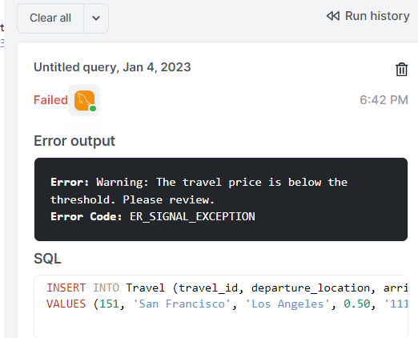

**2:**

a trigger for the Ticket table, which will generate a warning message when an attempt is made to insert a ticket with a price less than 0:

CREATE TRIGGER check_ticket_price

BEFORE INSERT ON Ticket

FOR EACH ROW

BEGIN

    -- Check if the ticket price is less than 0

    IF NEW.price < 0 THEN

        -- Raise a warning

        SIGNAL SQLSTATE '45000'

        SET MESSAGE_TEXT = 'Warning: Ticket price should not be less than 0.';

    END IF;

END

To check if it Works:

INSERT INTO Ticket (ticket_id, arrival_time, seat_number, departure_time, departure_location, arrival_location, price, user_ssn)

VALUES (1, '2028-01-01 12:00:00', '1', '2028-01-01 10:00:00', 'CityA', 'CityB', -50.00, '111-22-3333');

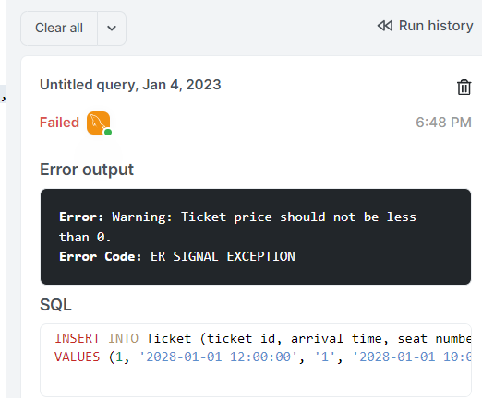

**3:**

This trigger will activate before an INSERT operation, and it will check if the email provided already exists in the table. If it does, it will raise a warning:

CREATE TRIGGER before_insert_passenger

BEFORE INSERT ON Passenger

FOR EACH ROW

BEGIN

  DECLARE email_count INT;

  -- Check if the email already exists

  SELECT COUNT(*) INTO email_count

  FROM Passenger

  WHERE email = NEW.email;

  -- If email already exists, raise a warning

  IF email_count > 0 THEN

    SIGNAL SQLSTATE '45000'

    SET MESSAGE_TEXT = 'Email already exists. Please use a different email.';

  END IF;

END;

To check if it Works:

INSERT INTO Passenger (ssn, phone_no, email, location, name, date_of_birth, gender, balance, preference)

VALUES ('181-22-3333', '123-456-7890', 'existing_email@example.com', 'New York', 'John Doe', '1990-01-01', 'Male', 100.00, 'Train');

INSERT INTO Passenger (ssn, phone_no, email, location, name, date_of_birth, gender, balance, preference)

VALUES ('191-22-3333', '123-456-7890', 'existing_email@example.com', 'New York', 'John Doe', '1990-01-01', 'Male', 100.00, 'Train');

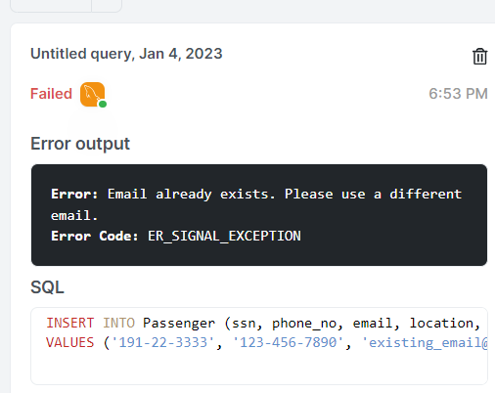

(3 pts) Write down 3 meaningful check constraints.

1)

This check constraint ensures that the price of a ticket is always a positive value.

ALTER TABLE Ticket

ADD CONSTRAINT chk_positive_price CHECK (price >= 0);

2)

This check constraint ensures that the gender of a passenger is either 'Male' or 'Female' :

ALTER TABLE Passenger

ADD CONSTRAINT chk_valid_gender CHECK (gender IN ('Male', 'Female'));

**3)**

This check constraint ensures that the balance of a user is always equal to or greater than zero:

ALTER TABLE passenger

ADD CONSTRAINT chk_positive_balance CHECK (balance >= 0);

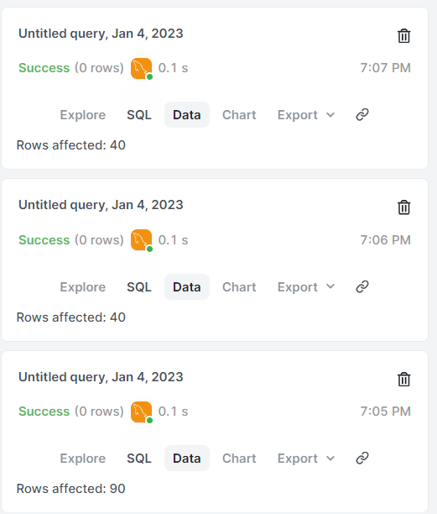

All check constraints are working full functionally.

(3 pts) Write sample INSERT, DELETE and UPDATE statements for 3 of the tables you have chosen.

UPDATE Passenger

SET email = 'john.doe@example.com', balance = 120.00

WHERE ssn = '111-22-3333';

-- Deleting a passenger

DELETE FROM Passenger

WHERE ssn = '1991-22-3333';

-- Inserting a new passenger

INSERT INTO Passenger (ssn, phone_no, email, location, name, date_of_birth, gender, balance, preference)

VALUES ('191-22-3333', '555-1234', 'john.doe@example.com', 'CityA', 'John Doe', '1990-05-15', 'Male', 100.00, 'Bus');

-- Inserting a new transportation record (e.g., Bus)

INSERT INTO Transportation (transportation_id, type, capacity)

VALUES (101, 'Bus', 50);

-- Updating transportation record (e.g., Bus capacity)

UPDATE Transportation

SET capacity = 55

WHERE transportation_id = 101;

-- Deleting a transportation record

DELETE FROM Transportation

WHERE transportation_id = 101;

-- Inserting a new ticket

INSERT INTO Ticket (ticket_id, arrival_time, seat_number, departure_time, departure_location, arrival_location, price, user_ssn, transportation_id)

VALUES (1, '2028-01-01 12:00:00', 'A1', '2028-01-01 10:00:00', 'CityA', 'CityB', 50.00, '111-22-3333', 101);

-- Updating ticket price

UPDATE Ticket

SET price = 60.00

WHERE ticket_id = 1;

-- Deleting a ticket

DELETE FROM Ticket

WHERE ticket_id = 1;

Write 5 SELECT statements for the database you have implemented. i. (2 pts) 2 of them should use a minimum of 2 tables.

1)

-- Selecting information about a passenger and their ticket

SELECT

    P.name AS passenger_name,

    P.location AS passenger_location,

    T.ticket_id,

    T.departure_location,

    T.arrival_location,

    T.price

FROM

    Passenger P

JOIN

    Ticket T ON P.ssn = T.user_ssn

WHERE

    P.ssn = '111-22-3333';

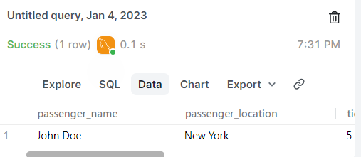

2)

    -- Retrieve passenger information with associated ticket details

    SELECT

        p.ssn,

        p.name,

        p.location,

        t.ticket_id,

        t.departure_location,

        t.arrival_location,

        t.departure_time,

        t.arrival_time,

        t.price

    FROM

        Passenger p

    JOIN

        Ticket t ON p.ssn = t.user_ssn;

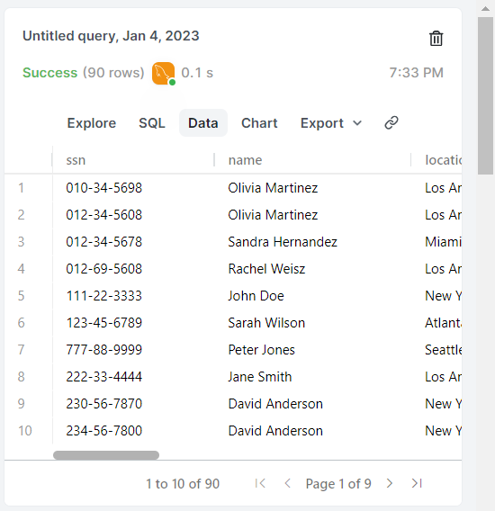

ii. (3 pts) 3 of them should use a minimum of 3 tables.

1)

-- Retrieve information about a specific passenger, their associated ticket, and details about the transportation type

SELECT

    p.ssn AS passenger_ssn,

    p.name AS passenger_name,

    p.email AS passenger_email,

    t.ticket_id,

    t.departure_location,

    t.arrival_location,

    t.departure_time,

    t.arrival_time,

    t.price,

    tr.type AS transportation_type

FROM

    Passenger p

JOIN

    Ticket t ON p.ssn = t.user_ssn

JOIN

    Transportation tr

WHERE

    p.ssn = '111-22-3333';

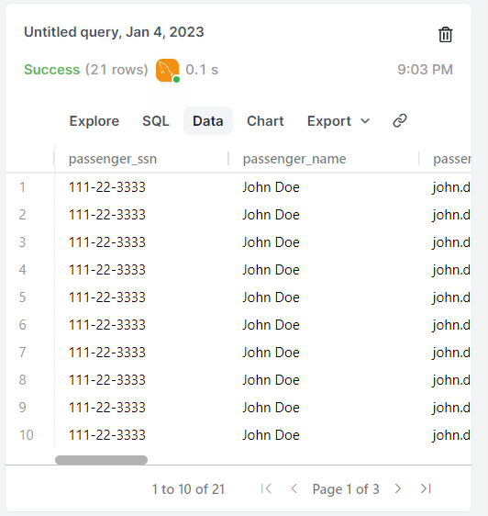

2)

-- Selecting names of people who used a plane and born before 1990

SELECT DISTINCT p.name, p.date_of_birth

FROM Passenger p

JOIN Travel t ON p.ssn = t.passenger_ssn

JOIN Transportation tr ON t.transportation_id = tr.transportation_id

WHERE tr.type = 'Plane' AND p.date_of_birth < '1990-01-01';

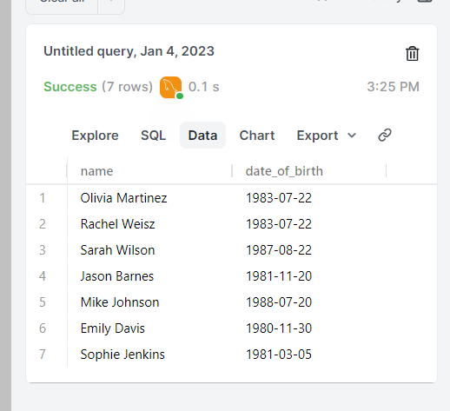

3)

-- Selecting travels for passengers who used a scooter after 2023-09-09

SELECT t.travel_id, p.name AS PassengerName, p.ssn AS PassengerSSN, s.location AS ScooterLocation, t.travel_start_date

FROM Travel t

JOIN Passenger p ON t.passenger_ssn = p.ssn

JOIN Scooter s ON t.transportation_id = s.transportation_id

WHERE t.travel_start_date > '2023-09-09' AND s.location IS NOT NULL;

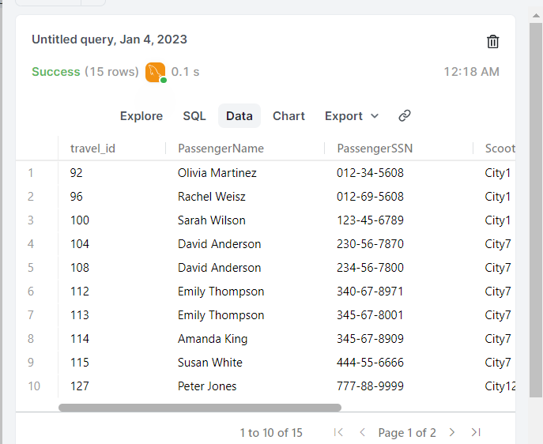

(2 pts for each) Write 4 original SELECT statements that you think are critical.

1)

-- Selecting passengers who used plane from Travel table

SELECT DISTINCT p.ssn, p.name, p.email

FROM Passenger p

JOIN Travel t ON p.ssn = t.passenger_ssn

JOIN Transportation tr ON t.transportation_id = tr.transportation_id

WHERE tr.type = 'Plane';

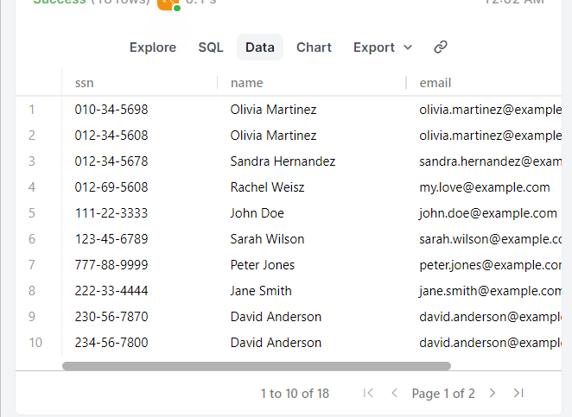

2)

-- Selecting bus firm names sorted by user count using Travel table

SELECT b.firm_name AS BusFirm, COUNT(DISTINCT p.ssn) AS UserCount

FROM Travel t

JOIN Passenger p ON t.passenger_ssn = p.ssn

JOIN Bus b ON t.transportation_id = b.transportation_id

GROUP BY b.firm_name

ORDER BY UserCount DESC;

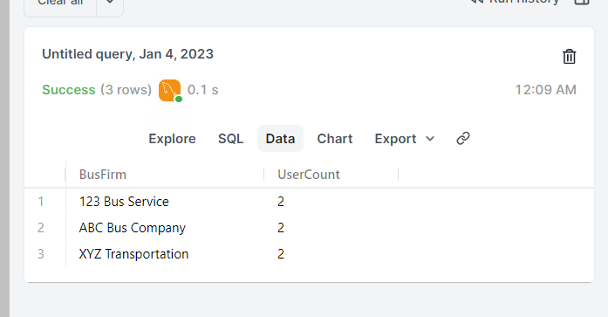

3)

-- Selecting user count by transportation preferences

SELECT p.preference, COUNT(DISTINCT p.ssn) AS UserCount

FROM Passenger p

JOIN Travel t ON p.ssn = t.passenger_ssn

GROUP BY p.preference

ORDER BY UserCount DESC;

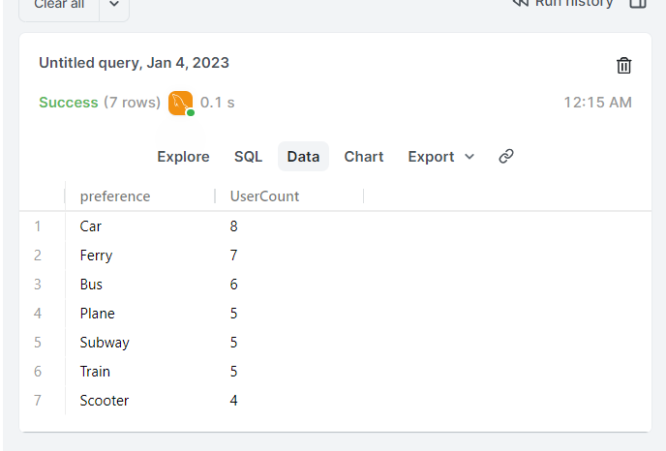

4)

--- spesificly one person type history

SELECT passenger.name, passenger.ssn, transportation.type

FROM Passenger

JOIN Travel ON passenger.ssn = travel.passenger_ssn

JOIN Transportation ON travel.transportation_id = transportation.transportation_id

WHERE passenger.ssn = '777-88-9999'

GROUP BY passenger.name, passenger.ssn, transportation.type;

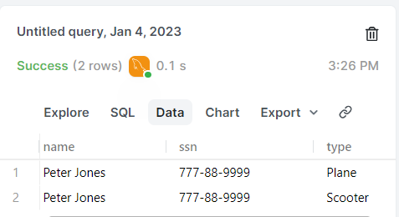

Some extra SQL statements:

-----------------

-- Counting transportation types and their usage

SELECT transportation.type, COUNT(travel.travel_id) AS UsageCount

FROM Travel

JOIN Transportation ON travel.transportation_id = transportation.transportation_id

GROUP BY transportation.type

ORDER BY UsageCount DESC;

--------------

SELECT

    p.name AS passenger_name,

    p.email AS passenger_email,

    t.ticket_id,

    t.departure_location,

    t.arrival_location,

    t.price

FROM Passenger p

JOIN Ticket t ON p.ssn = t.user_ssn

WHERE p.ssn = '123-45-6789';

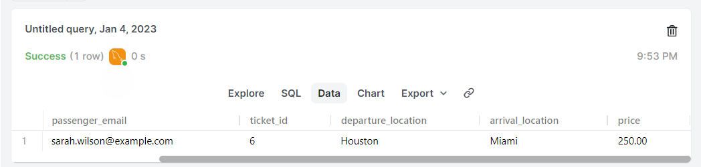

-- Selecting tickets with passenger information

SELECT t.ticket_id, t.departure_location, t.arrival_location, t.price, p.name, p.email

FROM Ticket t

JOIN Passenger p ON t.user_ssn = p.ssn

WHERE t.departure_location = 'New York' AND t.arrival_location = 'Chicago';



